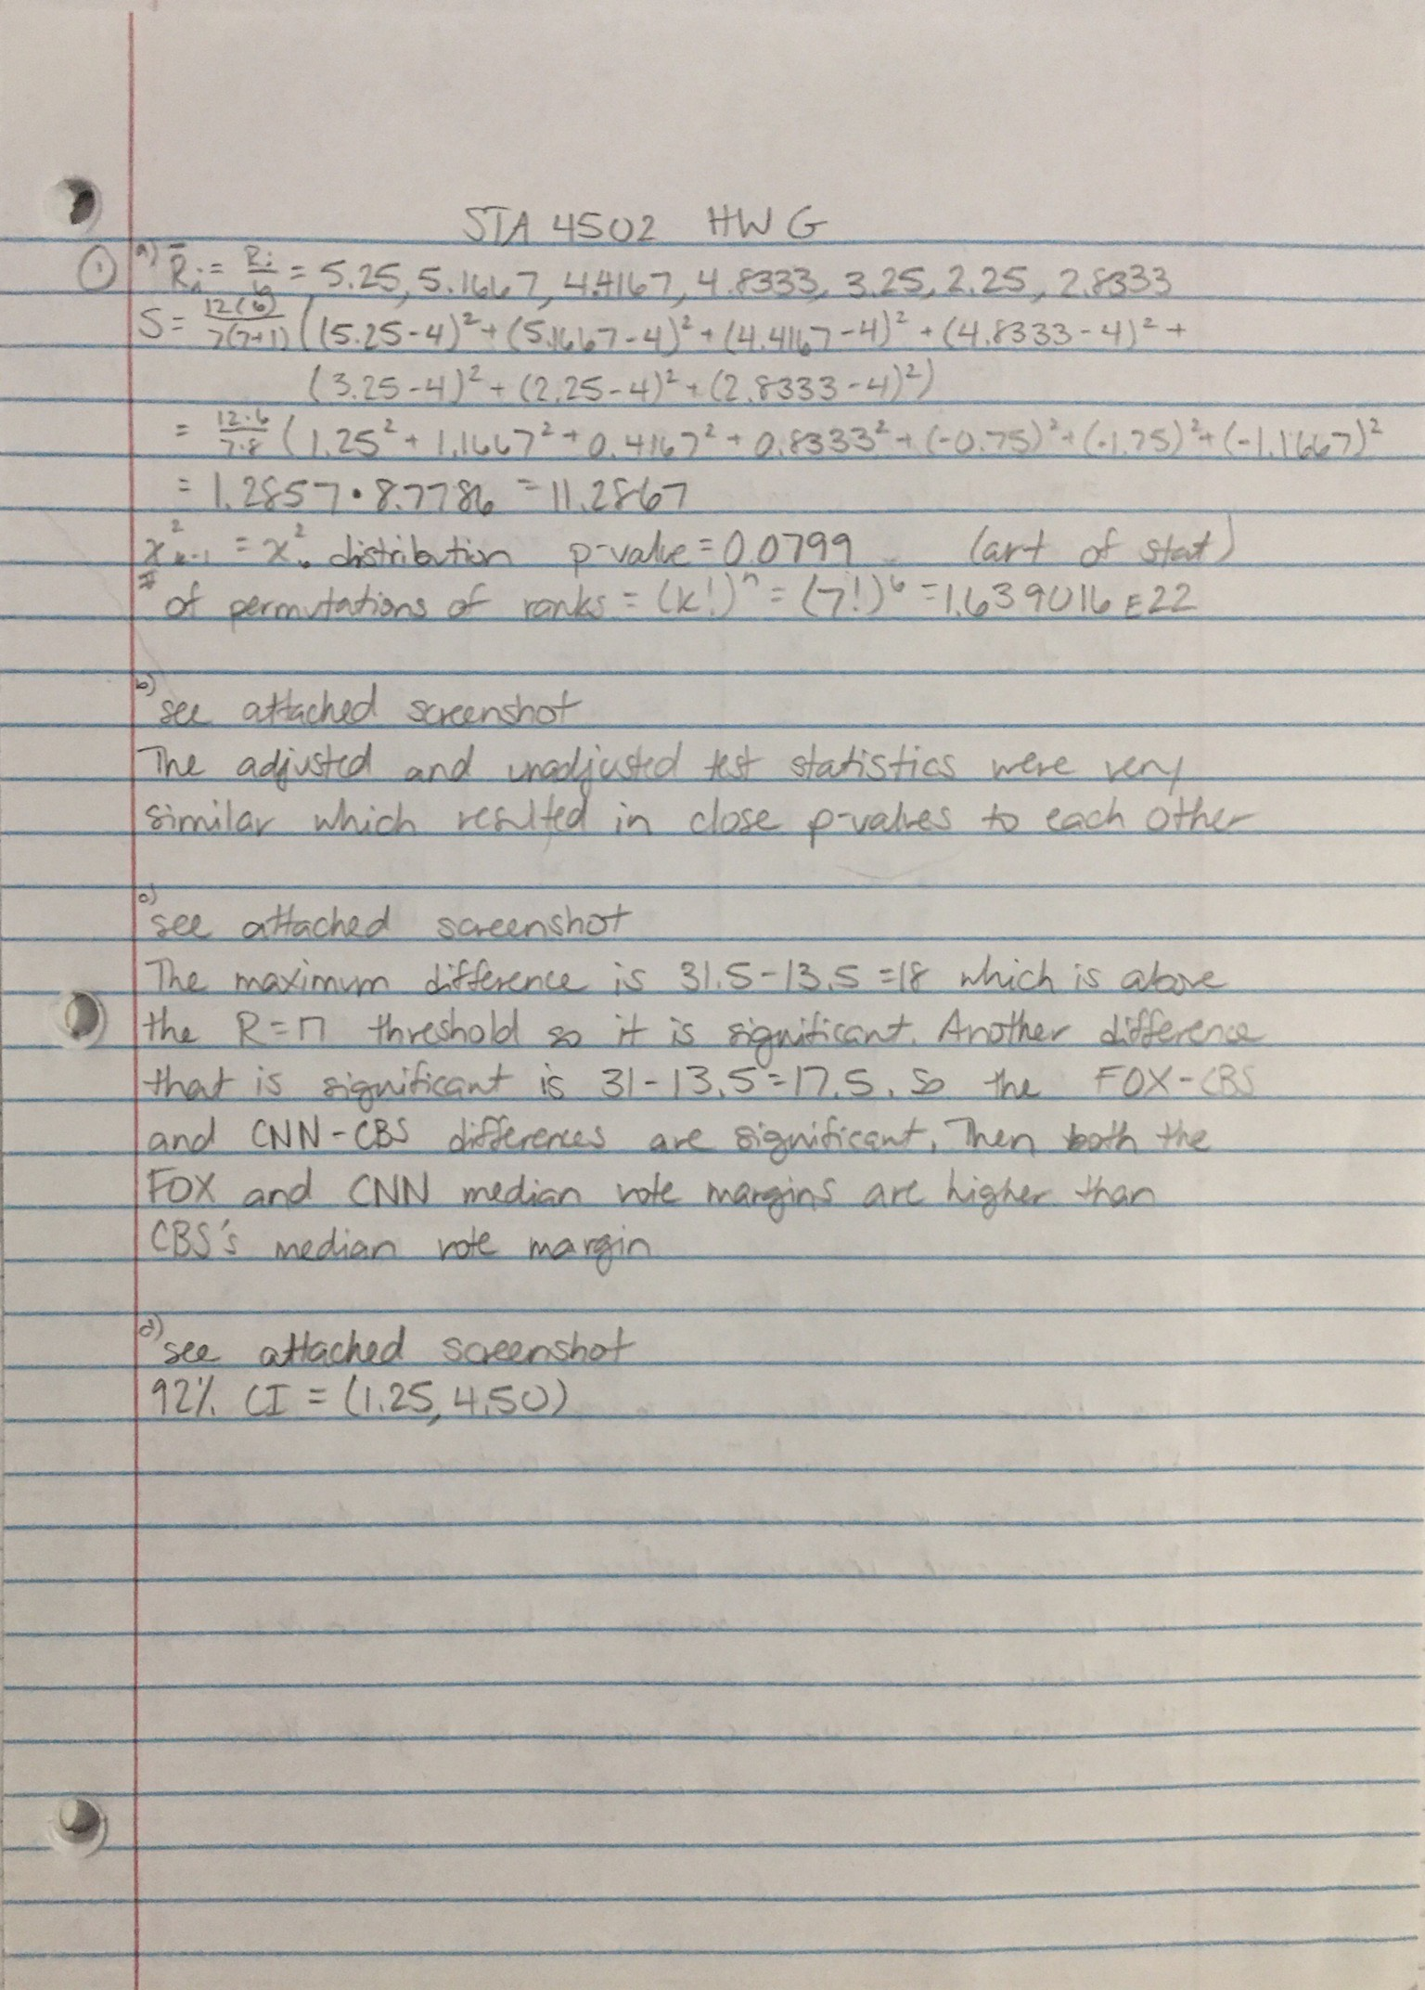
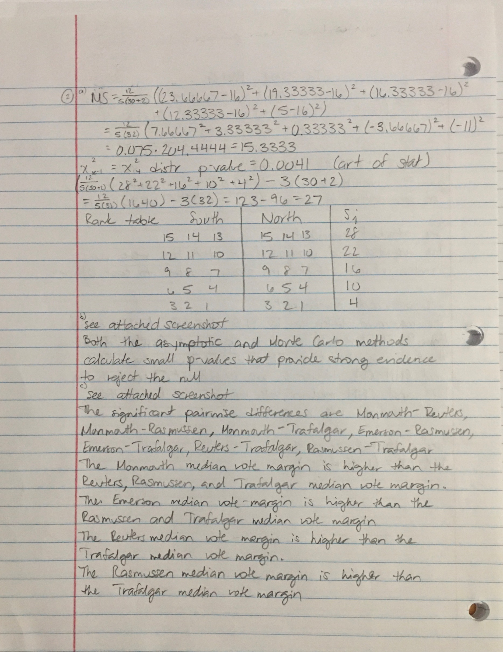
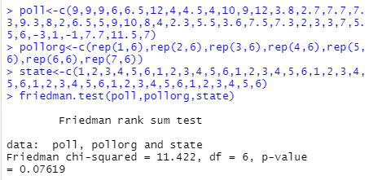
1b

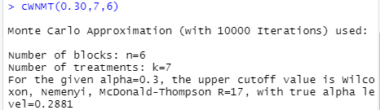
1c

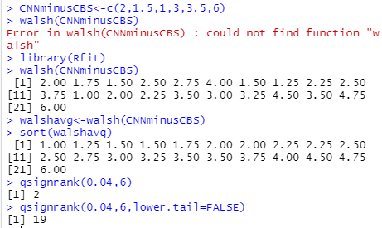
1d

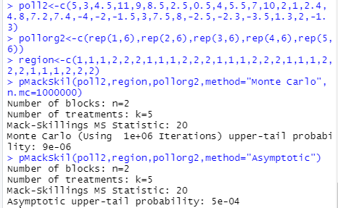
2b

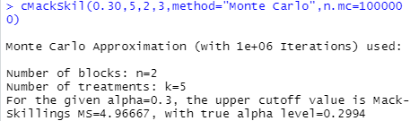
2c

2d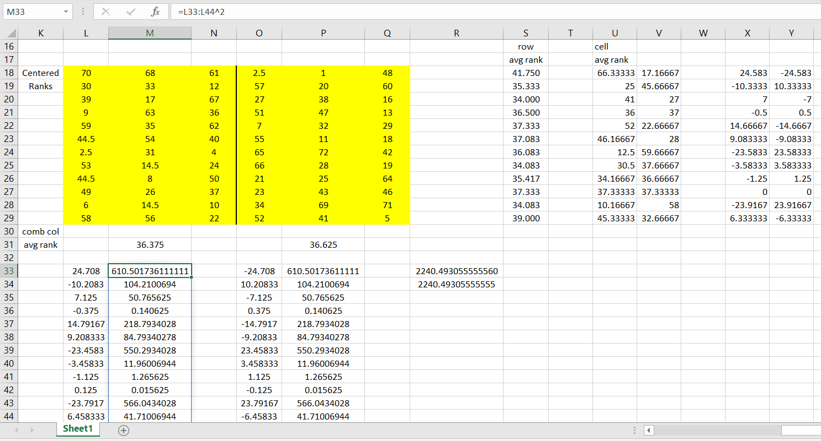
Excel formatting:
X18-X29=U18:U29-S18:S29
Y18-Y29=V18:V29-S18:S29
L33-L44=X18:X29-M31+36.5
O33-O44=X18:X29-P31+36.5
M33-M44=L33:L44^2
P33-P44=O33:O44^2
R33=SUM(M33:M44)
R34=SUM(P33:P44)
$Q=\frac{12*3}{72*73}\left(2240.493055555+2240.493055555\right)= 30.69168569$
Chi-squared distribution with 11 df – p-value=0.0012
The polls that are making the greatest contribution towards the moderately significant interaction effect are FOX, CNBC, ABC, and Rasmussen.

